## R Markdown

This is an R Markdown document. Markdown is a simple formatting syntax for authoring HTML, PDF, and MS Word documents. For more details on using R Markdown see <http://rmarkdown.rstudio.com>.

#########################################################################  
# Problem 1  
#########################################################################  
  
rnormalBX <- function(n=1, mean = 0, var = 1, seed = NULL){  
   
 if(!is.null(seed)) set.seed(seed) # set seed for the random number  
   
 # generate two uniform and then calculate r and theta and finally generate normal random number  
   
 u = runif(n, 0, 1)  
 v = runif(n, 0, 1)  
 r = sqrt(-2*log(v))  
 theta = 2*pi*u  
 norm = cbind(r*cos(theta), r*sin(theta))  
 if(n != 1) {norm = (norm - colMeans(norm))/sqrt(diag(var(norm)))}  
  
 # transform normal random number with specified mean and variance   
   
 if (mean != 0 || var != 1){  
 norm = sqrt(var)*norm + mean  
   
 }  
 return(unname(norm, force = TRUE))  
 }  
  
# # calling rnormalBX function to generate normal random number using Box-Muller algorithm  
# x = rnormalBX(n = 1000, mean = 0, var = 1, seed = 123)  
# summary(x)  
  
  
rcauchydist <- function(n=1, seed = NULL){  
 x = rnormalBX(n = n, mean = 0, var = 1, seed = seed)  
 return(x[,1]/x[,2])  
}  
  
x = rcauchydist(1000, seed = 4578)  
#Part 1 Independence of two normal random variable generated using Box-Muller algorithm  
  
  
  
# Density Curve for the normal sample. Function densityCurve has two parameters, data = data set for the density curve, dist = distribution.  
  
densityCurve <- function(data , nbreaks = NULL){  
  
 if(is.null(nbreaks)){ nbreaks = pretty(data)}  
 title = "Histogram with Cauchy Curve"  
 his <- hist(data, breaks = nbreaks, freq = FALSE, col="red", xlab="x", main=title, xlim = c(-30,30))  
 xfit <- his$mids   
 yfit <- dcauchy(xfit, location = 0, scale = 1)  
 lines(xfit, yfit, col="blue", lwd=2)  
  
 }  
  
# Calling densityCurve function to create density curve.  
densityCurve(x, nbreaks = 500)

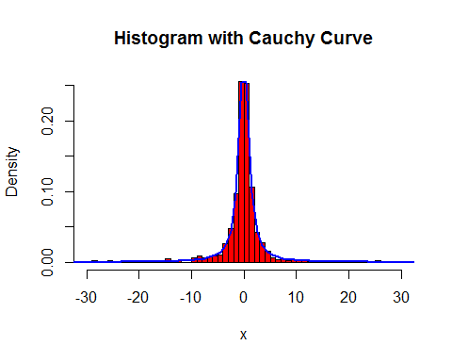

# problem 1 part 2  
  
cauchyMeanForEachSample <- function(samSize = 1:100, seed = NULL){  
 if(!is.null(seed)) set.seed(seed)  
 return(apply(as.array(samSize), 1, function(x) mean(rcauchydist(x))))  
}  
  
seq = seq.int(1,10^4, 50)  
cmean = cauchyMeanForEachSample(seq, seed = 245)  
plot(seq, cmean)

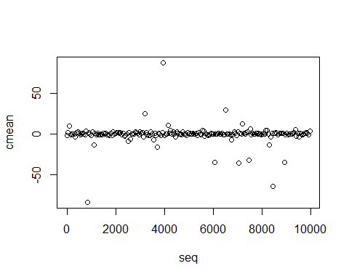

# problem 1 part 3  
  
cauchyMeanSim <- function(samSize = 100, distSize = 1000 , seed = NULL){  
 if(!is.null(seed)) set.seed(seed)  
 meandist = replicate(distSize, mean(rcauchydist(samSize)))  
  
 return(meandist)  
}  
  
cmean = cauchyMeanSim(40, distSize = 2000, seed = 365)  
densityCurve(cmean, nbreaks = 800)

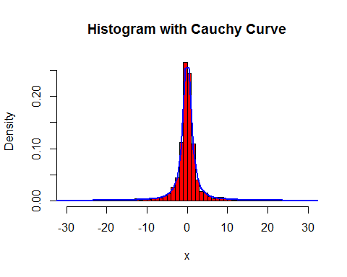

cmean = cauchyMeanSim(100, distSize = 2000, seed = 365)  
densityCurve(cmean, nbreaks = 1300)

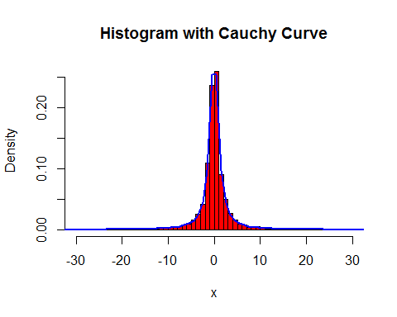

cmean = cauchyMeanSim(500, distSize = 2000, seed = 4125)  
densityCurve(cmean, nbreaks = 1500)

